Ship Scantling Optimization

Based on Least Production Cost Objective Function

Philippe RIGO

University of Liege, Dept. of Naval Architecture (ANAST), Chemin des Chevreuils n°1, B52/3
B-4000 Liege, Belgium
Tel: +32-(0) 43.66.93.66; Fax: +32-(0) 43.66.91.33; Email: ph.rigo@ulg.ac.be
(National Fund for Scientific Research of Belgium - NFSR)

PART II THE CONSTRAINT MODULE
- Structural and Geometrical Constraints -

Ph Rigo (March 2001)

The problems to be solved can be summarised as follows:
- X_{i} i = 1, N, the N design variables,
- F(X_{i}) the objective function to minimize,
- Cj(X_{i}) ≤ CM_{j} j = 1,M the M structural and geometrical constraints,
- X_{i min} ≤ X_{i} ≤ X_{i max} upper and lower bounds of the X_{i} design variables: technological bounds (also called side constraints).

Constraints are linear or non-linear functions, either explicit or implicit of the design variables (XI). These constraints are analytical translations of the limitations that the user wants to impose on the design variables themselves or to parameters like displacement, stress, ultimate strength, etc. Note that these parameters are functions of the design variables.
So one can distinguish:
- Technological constraints (or side constraints) that provide the upper and lower bounds of the design variables.
for example: Xi min = 4mm ≤ Xi ≤ Xi max = 40 mm,
with: Xi min a thickness limit dues to corrosion, etc;
Xi max a technological limit of manufacturing or assembly.
- Geometrical constraints impose relationships between design variables in order to guarantee a functional, feasible, reliable structure. They are generally based on “good practice” rules to avoid local strength failures (web or flange buckling, stiffener tripping, etc.), or to guarantee welding quality and easy access to the welds. For instance, welding a plate of 30 mm thick with one that is 5 mm thick is not recommended.
Example: 0.5 ≤ X2 / X1 ≤ 2
with X1, the web thickness of a stiffener and X2, the flange thickness.
- Structural constraints represent limit states in order to avoid yielding, buckling, cracks etc. and to limit deflection, stress, etc. These constraints are based on solid-mechanics phenomena and modeled with rational equations. By rational equations, we mean a coherent and homogeneous group of analysis methods based on physics, solid mechanics, strength and stability treatises, etc. and that differ from empirical and parametric formulations.
Thus, these rational structural constraints can limit:
• Deflection level (absolute or relative) in a point of the structure,
• Stress level in an element (σ_{x}, σ_{y} and σ_{c} = σ_{von Mises}),
• Safety level related to buckling, ultimate resistance, tripping, etc. (Example: σ / σ_{ult} ≤ 0.5).

For each constraint, or solid-mechanics phenomenon, the selected behavior model is especially important since this model fixes the quality of the constraint modeling.
These behavior models can be so complex that it is no longer possible to explicitly express the relation between the parameters being studied (stress, displacement, etc.) and the design variables (XI). This happens when one uses mathematical models (FEM, LBR-4, etc.). In this case, one generally uses a numeric process that consists of replacing the implicit function by an explicit "approximated function" adjusted in the vicinity of the initial values of the design variables (for instance using the Taylor series expansions). This way, the optimization process becomes an iterative analysis based on a succession of local approximations of the behavior models.

The list of constraints included in the LBR-5 model is intimately bound to the types of structures targeted by this research. Let's recall that these are mainly metallic, prismatic (box girders) and stiffened (orthotropic) structures used for hydraulic and marine structures.
These structures are composed of stiffened panels that are either cylindrical or plane. The panels are joined one to another by generating lines (edges of the prismatic structure) and are stiffened longitudinally and transversely (Figs. II.1 and 2).

- Stiffened longitudinally:
- by stiffeners,
and/or
- by crossbars and girders, prompt elements of strong rigidity.

- Stiffened transversely:
- by transverse bulkheads, (Fig. II.1a).
and/or
- by the main transverse framing, (Fig. II.1b).
and/or
- by secondary or local transverse stiffeners, (Fig. II.1c).

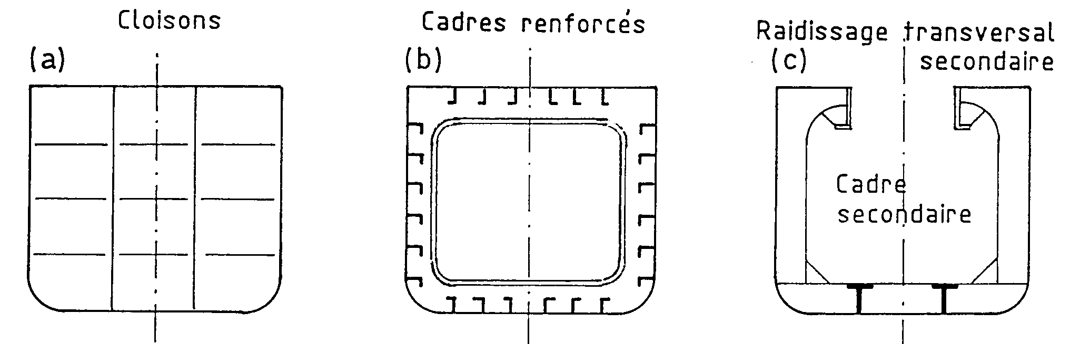
Bulkheads
Main Transverse Frame
Secondary Transverse
Frames .
Transverse
Stiffeners

Fig. II.1. Types of transverse framing.

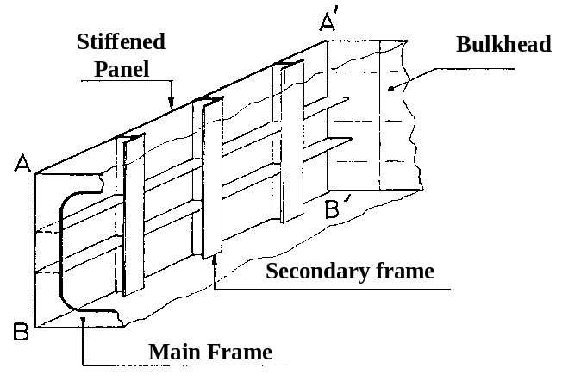

Fig. II.2: A stiffened panel.

When going from the "local" to the "general" (Fig. II.2), one differentiates three types of constraints:
- constraints on panels and components,
- constraints on frames and transversal stiffening,
- constraints on the global structure.

- Constraints on stiffened panels (Fig. II.2).
Panels are limited by their lateral edges (junctions with other panels, AA'' and BB'') either by watertight bulkheads or transverse frames. These panels are orthotropic plates and shells supported on their four sides, laterally loaded (bending) and submitted, at their extremities, to in-plane loads (compression/tensile and shearing).
Global buckling of panels (including the local transverse frames) must also be considered.
Panel supports, in particular those corresponding to the reinforced frames, are assumed infinitely rigid. This means that they can distort themselves significantly only after the stiffened panel collapse.

- Constraints on the transverse frames (Figs. II.1 and 2)
The frames take the lateral loads (pressure, dead weight, etc.) and are therefore submitted to combined loads (large bending and compression). The rigidity of these frames must be assured in order to respect the hypotheses on panel boundary conditions (undeformable supports).

- Constraints on the global structure (box girder/hull girder) (Figure II.3).
The ultimate strength of the global structure or a section (block) located between two rigid frames (or bulkheads) must be considered as well as the elastic bending moment of the hull girder (against yielding).

The limit states that will be considered are:
- A service limit state that corresponds to a situation where the structure can no longer assure the service for which it was conceived (examples: excessive deflection cracks).
- An ultimate limit state that corresponds to collapse/failure.

It is important to differentiate service limit states to ultimate limit states because safety factors associated to these two limit states are generally different.

Ultimate Limit States
For a structure submitted to a global bending moment, the ultimate limit state is usually symbolised by point C of the moment-curvature curve (M-Φ) shown at Fig. II.3. The ultimate state is reached when the structure can no longer support a complementary increase in the bending moment without "collapsing" completely (point D).

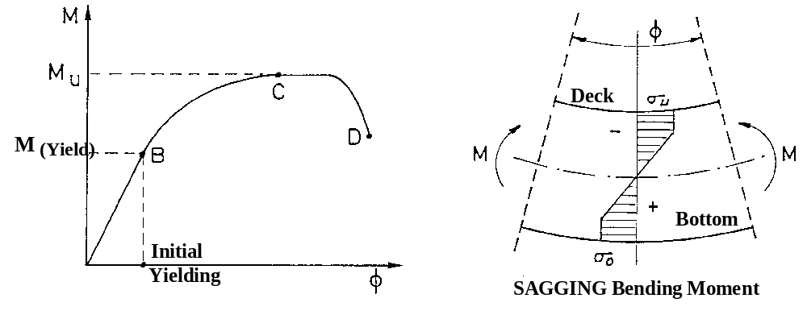

Fig. II.3. The moment-curvature curve (M-Φ).
M_{u} is therefore the ultimate bending moment of the global structure. Its computation depends closely on the ultimate strength of this structure's constituent panels, and particularly on the ultimate strength in compression of these panels or components [63]. Fig. II.3 shows that in "sagging", the deck is compressed (σ_{deck}) and reaches the ultimate limit state when σ_{deck} = σ_{u}. On the other hand, the bottom is in tensile and reaches its ultimate limit state after complete yielding, σ_{bottom} = σ_{o} (σ_{o} being the yield stress).

In conclusion, to determine the global ultimate bending moment (M_{u}), one must know in advance both the ultimate strength in compression of each panel (σ_{u}) and the average stress-average strain relationship (σ−ε) in order to perform a progressive collapse analysis.

Fig. II.4 presents the different structure levels: the global structure or general structure (level 1), the orthotropic stiffened panel (level 2) and the interframe longitudinally stiffened panel and its simplified modeling: the beam-column (level 3 and 3bis).

The relations between the different limit states and structure levels can be summarized as follows:

➔ Level 1:
Ultimate bending moment of the global structure: M_{u}

➔ Level 2:
Ultimate strength of compressed orthotropic stiffened panels (σ_{u}).
σ_{u} = min [σ_{u} (mode i), i = a, b, c and d, the 4 considered failure modes]

➔ Level 3:
Mode a: Global buckling.
Mode b: P_{ult} of interframe panels:
Beam-column models or orthotropic models considering:
- plate induced failure (buckling),
- stiffener induced failure (buckling or yielding).
Mode c: Instability of stiffeners (local buckling, tripping, etc.).
Mode d: Yielding.

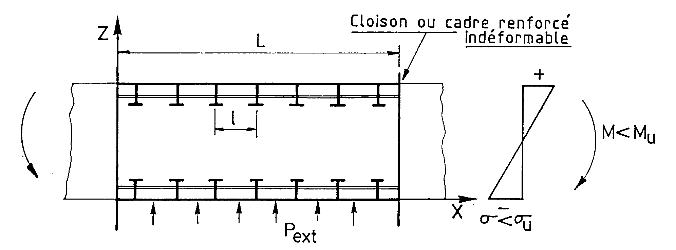
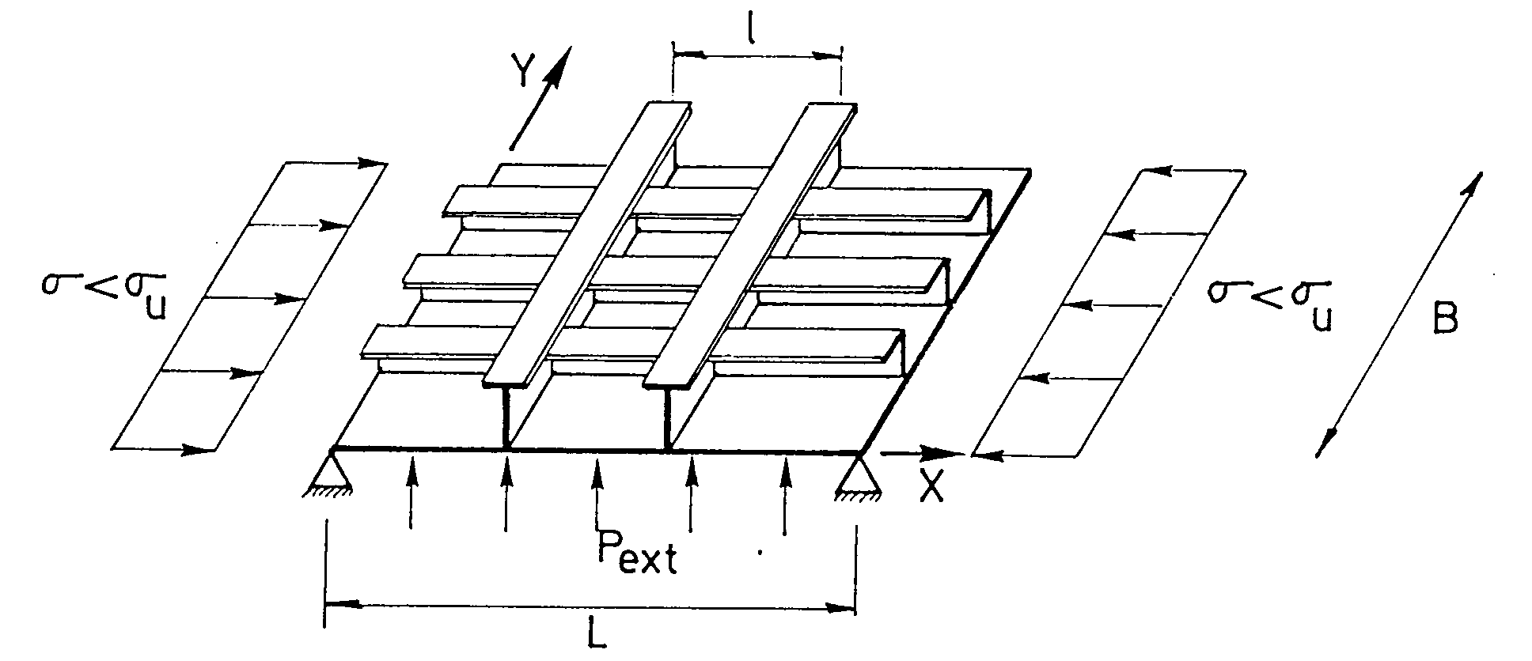
P_{lat}
P_{lat}
P_{lat}

Level 1: Global structure (or part of the structure between 2 bulkheads)

Level 2: The whole panel (stiffened/orthotropic panel)

Level 3: Level 3bis:
Interframe panel: The simplified
between 2 frames or 2 transverse stiffeners beam-column model

Fig. II.4. Structural modeling of the structure and its components.
To avoid constraints related to the “a” mode, one generally imposes a minimal rigidity for the transverse frames so that an interframe panel collapse (mode b) always appears before global buckling (mode a). It is a "simple" and "easy" constraint to implement, thus avoiding any complex calculation of global buckling (mode a).
Let's note that the “b” failure mode is influenced by the buckling strength of the unstiffened plate (elementary unstiffened plate). This limit state is usually not considered as the ultimate limit state, but rather as a service limit state.

In the LBR-5 model, all the available constraints are classified as follows:
1. Stiffened panels constraints:
Service limit states
1.1. Upper and lower bounds (Xmin ≤ X ≤ Xmax): plate thickness, dimensions of longitudinals and transverse stiffeners (web, flange and spacing).
1.2. Maximum allowable stresses against yielding.
1.3. Panel deflection (local deflection).
1.4. Buckling of unstiffened plates situated between two longitudinals and two transverse stiffeners (frames/bulkheads)
1.5. Local buckling of longitudinal stiffeners (web and flange).

Ultimate limit States
1.6. General buckling of orthotropic panels (global stiffened panels).
1.7. Ultimate strength of interframe longitudinally stiffened panel.
1.8. Torsional-flexural buckling of stiffeners (tripping).

2. Frames constraints.
Service limit states
2.1. Upper and lower bounds (Xmin ≤ X ≤ Xmax)
2.2. Minimal rigidity to guarantee rigid supports to the interframe panels (between 2 transverse frames).
2.3. Allowable stresses under the combined loads (M, N, T),
- Elastic analysis,
- Elasto-plastic analysis.

Ultimate limit states
2.4. Frame buckling,
- Buckling of the compressed members,
- Local buckling (web, flange).

N.B.: These limit states are considered as ultimate limit states rather than a service limit state. If one of them appears, the assumption of rigid supports is no longer verified and collapse of the global stiffened panels can occur.

- General constraints
Service limit states
3.1. Allowable stresses,
3.2. General deflection of the global structure and relative deflections of components and panels.

Ultimate limit states
3.3. Global ultimate strength (of the hull girder/box girder) between 2 frames or bulkheads.

NB: Collapse of frames is assumed to only appear after the collapse of panels located between these frames. This means that it is sufficient to verify the box girder ultimate strength between two frames to be protected against a more general collapse including, for instance, one or more frame spans.

As a relevant comparative reference, Table 1 shows the limit states selected by the "Ship Structure Committee (SSC n° 375 of 1994) [Hughes 1994]". For each limit state, the third column of this table makes references to a rational approach selected by O. Hughes to impose constraints (ultimate or service). As a comparison with the proposals achieved in the SSD (Ship Structural Design, [Hughes 1988]), Table II.1 also contains the constraint list selected for the LBR-5 model. Although different in several aspects (principles and methods), the two classifications perfectly match and exclude any collapse associated with a limit state not considered.

Failure Modes of Principal Members | Failure  Category | Computational Algorithm  Source  (SSD = Ship Structural Design) [Hughes 1988] | Reference  to available  constraints  in LBR-5.
GLOBAL STRUCTURE :  (Box girder/hull girder)  Ultimate Strength | Collapse | SSD Sec. 17-1 | 3.3
PANEL  Collapse  Stiffener Flexure  Combined Buckling  Membrane Yield  Stiffener Buckling  Stiffener Unseviceability  (Initial Yield)  Tension, Flange  Tension, Plate  Compression, Flange  Compression, Plate  Plate Unserviceability  Yield, plate bending  Local buckling  Allowable Permanent Set | (with  Collapse  Collapse  Collapse  Collapse  Yield  Yield  Yield  Yield  Yield  Unserv.  Yield | Longitudinal members)  SSD Sec. 14.2  SSD Sec. 13.2 - 13.4  SSD Sec. 12.5  SSD Sec. 13.1 & 15.5  Beam Theory & SSD Sec. 8.6  "  "  "  SSD Sec. 9.1 & 9.2  SSD Sec. 12.6  SSD Sec. 9.3 - 9.5 | 1.7  1.7  1.2 + 3.1  1.5 + 1.8  1.2  "  "  "  1.2 + 3.1  1.4  1.3 (a) + 3.2
BEAM | (Transverse | Members & frames)
Collapse  Tripping  Flexural-Torsional Buckling  Plastic Hinge  Unserviceability (Initial Yield)  Bending  Web shear | Collapse  Collapse  Collapse  Yield  Yield | SSD Sec. 13.1  SSD Sec. 15.4 & 15.5  SSD Sec. 16.1 & 16.2  Beam Theory  " " | 2.4  2.4  2.3 (b)  2.3  2.3
GRILLAGE  Collapse  Overall Buckling  Plastic Hinge | (Orthotropic  Collapse  Collapse | stiffened panels)  SSD Sec. 10.2 & 13.5,6  SSD Sec. 16.1 - 16.4 | 1.6 + 2.2  3.1 (b)
(a) A constraint on the relative elastic deflection is proposed.
(b) The considered limit state relates to the initial yielding and to ultimate strength

Table II.1: Identification of the collapse modes selected for the main components
of the structure [Hughes 1994]
PART IV LEAST COST OPTIMIZATION OF A FLOATING STORAGE OFFLOADING UNIT (FSO)

This least cost optimization example concerns the optimization of a FSO barge of 336 m with a capacity of 370,000 t, designed to serve as floating reservoir (provisory storage area) in view to receive crude oil before being transferred on board tankers (FSO = Floating Storage Offloading). It is a moored barge, without its own propulsion system with a 2,500,000-barrel capacity. The anchorage, independent of the barge, permits an almost free motion (Figs. IV.1 and 2). The barge is filled using a pipeline connected to the shore. The small discharge of the pipeline induces uniform and slow loading. On the other hand, the discharge of the FSO unit that corresponds to the filling of a 2,000,000 barrels VLCC (Very Large Crude Carrier), is very fast and not uniform. The main characteristics of the barge are given on Table IV.1.

Lpp (length between perpendiculars) | 336 m (10 + 6 x 46 + 50 m)
B (width) | 60 m (6 + 24 + 24 + 6 m)
H (depth) | 30 m
T (draft) | 20.5 m
C_{b} (block coefficient) | 0.95
Light Weight (Hull + propulsion devices) | 32,740 t
Number of crude oil tanks | 12 x 33,782 m³
Unit length of crude oil tanks | 46 m
Unit breadth of crude oil tanks | 24 m
Unit volume of crude oil tanks | 405,389 m³
Number of barrels (bbl) | 2,549,819 bbl (1 bbl = 0.1589873 m³)
Crude oil density | 0.93 t/m³ (9.3 kN/m³)
Water ballast : side hull | 59,600 m³
Water ballast : aft deep-tanks | 9,500 m³
Water ballast : fore deep-tanks | 20,000 m³
Tanks (fresh water and diesel-oil) | 1000 m³ et 2000 m³
Pumps | 4 x 1800m³/h and 977 kW
Total installed Power | 8880 kW
Thrusters (transversal thrust only) | 2 x 2500 kW et 300 kN/unit
Accommodation | 50 persons

Table IV.1. Main characteristics of the FSO barge
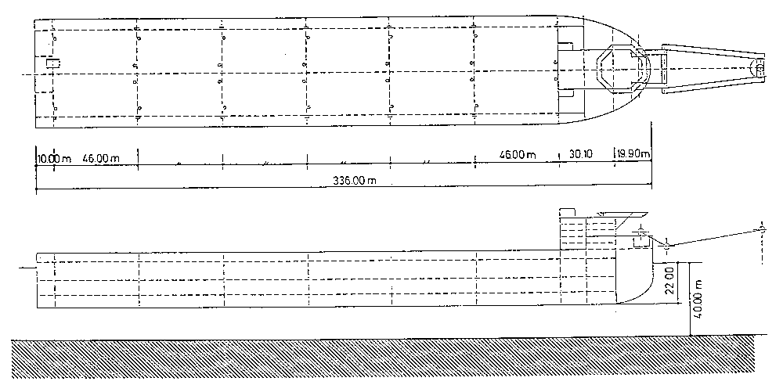

Fig. IV.1. General view of the FSO barge.
The optimization of a 46-m hold composed of two center tanks of 24 m x 30 m x 46 m and two lateral ballast tanks of 6 m in width was performed. The two considered loading cases are presented on Fig. IV.3 and the modeling is shown on Fig. IV.4. Based on structure symmetry, only half of the structure is modeled for structure optimization with the LBR-5 model. The maximal hull girder bending moment (without waves) has been valued at 670,000 t-m (6.57 10⁶ kN-m) and the shear force at 25,000 t (245,200 kN). This bending moment is particularly high by comparison to standard VLCC bending moment (±3 Mio kN.m). In addition, to take into account the wave bending moment, the optimum scantling was performed for a maximum bending moment of 10 Mio kN.m (hogging and sagging).
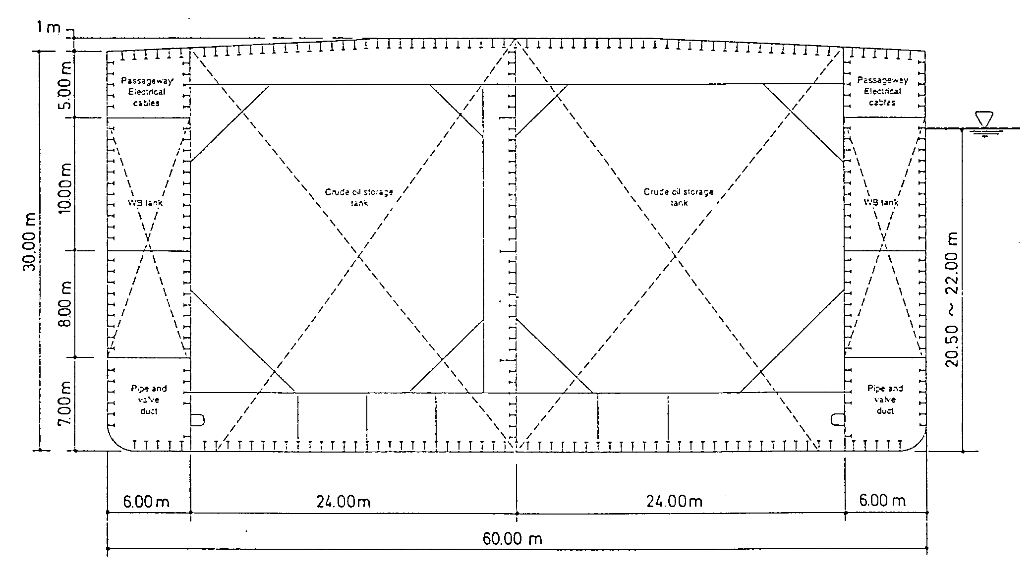
Crude Oil Storage tank
Crude Oil Storage tank
Passage
way
Pipe & Valve duct
Pipe & Valve duct
Electric
cables
WS
Tank
WS
Tank

Fig. IV.2. Midship section of the FSO barge

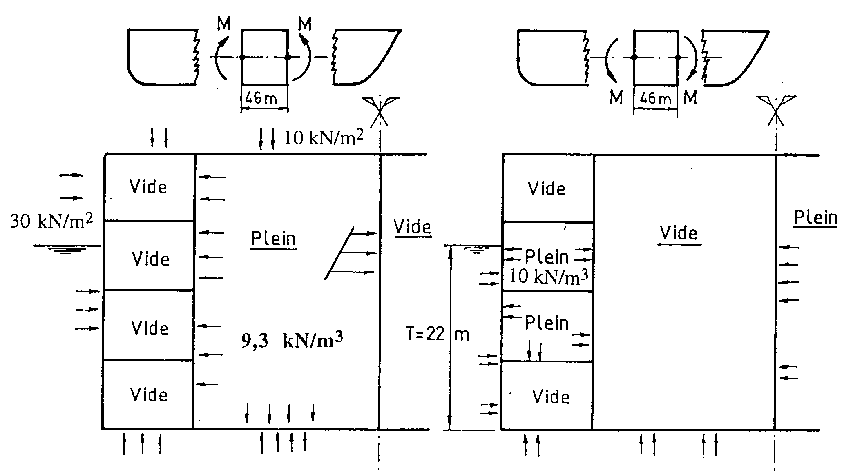
Empty
Empty
Empty
Empty
Empty
Empty
Empty
Empty
Full
Full

Bending in sagging Bending in hogging
Fig. IV.3. Considered loading cases.

In order to model the strong rigid bracket at each extremity of the tanks' transverse girders, the bottom panel of these center tanks (24 m in width) is modeled with three stiffened panels of 8-m wide in order to simulate a variable rigidity of these transverse members. Similarly, the longitudinal bulkheads and the deck are modeled with three elements each. Since the central bulkhead is on the symmetry axis, only half of its rigidity is taken into account in the model.
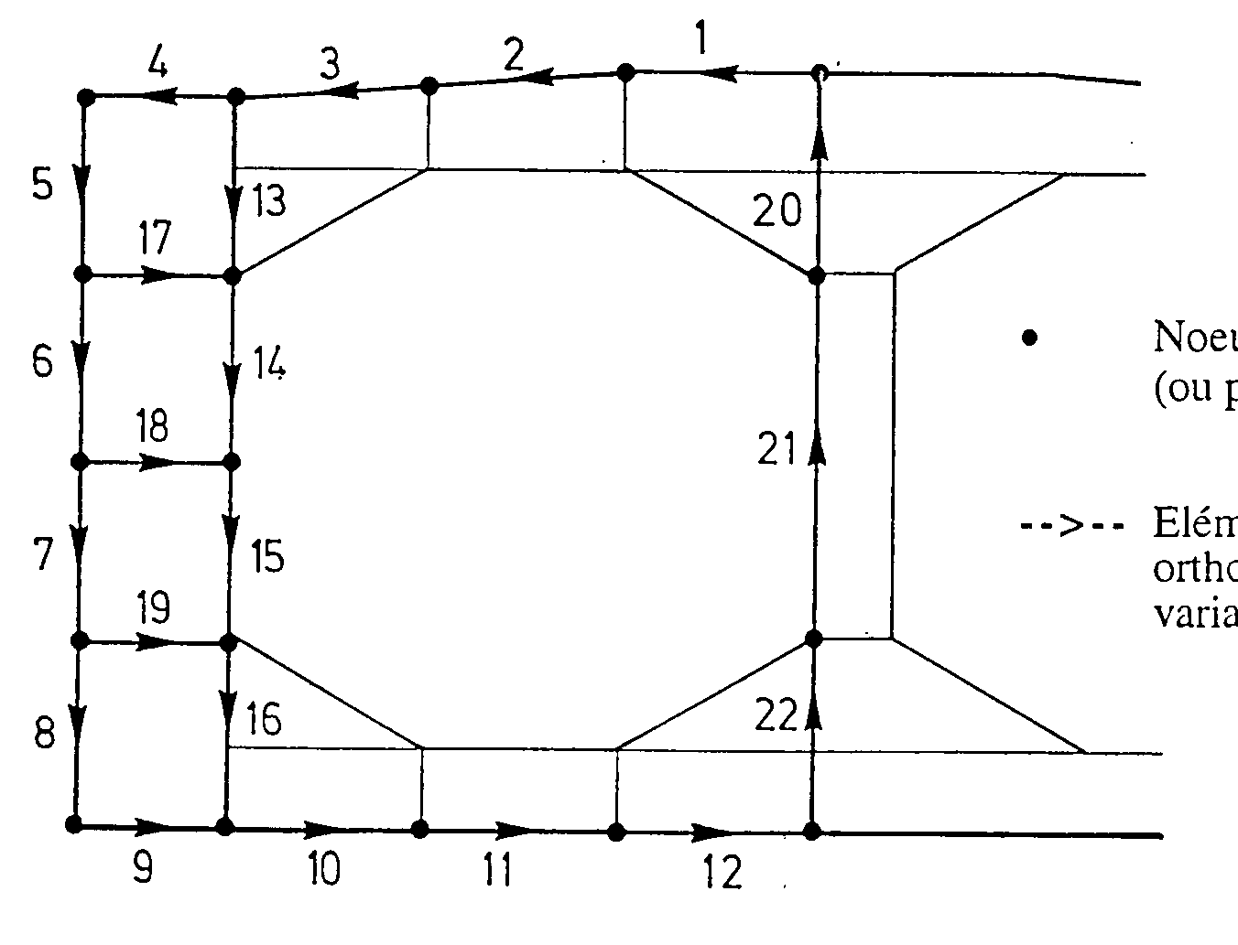

- Nodes between 2
(or more) elements

-->-- Elements
(or stiffened panels)
with 9 design
variables each.

Fig. IV.4. Mesh Modeling used for LBR-5 for the FSO Midship Section.

Optimum costs are calculated using the following cost and productivity data:
- Reference plate thickness: 10 mm
- Unitary Labor Cost (Euro/m-h)/Material Cost (Euro/t):
k = 0.08
- Unitary price of steel: C1 = 0.57 Euro/kg , ΔC1 = -0.6% (if AE235)
C1 = 0.65 Euro/kg, ΔC1 = -0.6% (if AE355)
- Price of welding (materials only): C8 = 1.00 Euro/m , ΔC8 = 15%
- Manpower:
- plate: P10 = 0.5 m-h/m² , ΔP10 = 7%
- frames (assembling with plate) : P4 = P5 = 1 m-h/m, ΔP4 = ΔP5 = 10%
- frames (if built on site): P9 = 0.5 m-h/m, ΔP9 = 1%

The mesh model of the FSO unit includes:
- 22 stiffened panels with 9 design variables each;
- 2 additional panels to simulate the symmetry axis (or boundary conditions);
- 198 design variables (9 x 22 panels);
- 48 equality constraints between design variables are used, e.g., to impose uniform frame spacing for the deck, bottom and central bulkhead in the center tanks and another one in the side ballast tanks.
- 198 geometrical constraints (9 x 22 panels). Since the web heights of longitudinal and transversal members are quite important, no geometrical constraints were selected for web slenderness. Web buckling stability and possibly their bracketing are then verified afterwards (post-optimization);
- 396 structural constraints (198 by load case):
- σ_{c} frame (web/plate junction – web/flange junction and flange),
σ_{c} stiffener (web/plate – web/flange and flange) and σ_{c} plate,
which should verified that σ_{c} ≤ s.σ_{o} (with s = 0.65 and σ_{o} = 355 N/mm²);
- local plate buckling: δ_{MIN} ≤ δ (with δ_{MIN} the minimum plate thickness to avoid buckling);
- ultimate strength of stiffened panel: σ/ σ_{ULT} ≤ s with s = 0.55 ;
- 2 constraints on the ultimate hull girder/box girder strength: M/M_{ULT} ≤ s (s = 0.55).
In order to define optimal scantlings (least cost and least weight), side constraints are imposed on the design variables (XI_{MAX}, XI_{MIN}). For instance, the upper limit for the (δ) plate thickness is fixed at 40 mm.

Other selected limits (side constraints) are:
2.87 m ≤ Δ_{Frames} ≤ 7.66 m
0.50 m ≤ Δ_{Stiffeners} ≤ 1.00 m
1.20 m ≤ h_{web} frames (center tanks) ≤ 6.00 m
0.50 m ≤ h_{web} frames (side tanks) ≤ 2.50 m (except in panels 13, 16, 18)
8.0 mm ≤ Web thickness ≤ 30.0 mm (or 40 mm)
..... etc.

Since the first results showed the importance of the ”δ ≤ 40 mm” side constraints, a second analysis was performed, imposing δ ≤ 30 mm. In addition, the frame spacing in the center tanks [Δc (center tanks)] and those in the side tanks [Δc (side tanks)] are considered to be independent. However, it is imposed that:
Δc (side tanks) = Δc (center tanks) / α with α an integer number lower than 3 (α ≤ 3).

Table 1 compares optima for six different configurations (C1 to C6):
- Optimum for δ (plating) ≤ 40 mm
- Least cost: C1: Δ _{FRAMES} (side tanks) = Δ _{FRAMES} (center tanks)
C2: Δ_{FRAMES} (side tanks) = ½ Δ _{FRAMES} (center tanks)
- Least weight: C3: Δ _{FRAMES} (side tanks) = Δ _{FRAMES} (center tanks)
C4: Δ _{FRAMES} (side tanks) = ½ Δ _{FRAMES} (center tanks)
- Optimum for δ (plating) ≤ 30 mm
- Least cost: C5: Δ _{FRAMES} (side tanks) = Δ _{FRAMES} (center tanks)
- Least weight: C6: Δ _{FRAMES} (side tanks) = Δ _{FRAMES} (center tanks)

Note that costs and weights refer to a half-structure (30-m wide) and that stiffening and bracketing (transverse members, webs, etc.) are not included in the weight.
Detailed optimal scantlings are presented in Figs. IV.5a-5b, Figs. IV.6a-6b and Figs. 10a-10b for, respectively, δ ≤ 40 mm (least cost), δ ≤ 40 mm (least weight) and δ ≤ 30 mm (least cost). The “raw” scantlings presented in these figures are not “ready to use”. They require minor changes such as rounded brackets in the corners, slow variation of the web height, etc. So, to establish execution plans and for practical and constructive reasons, greater standardization is advisable (examples: uniform thickness for the deck plate, side shell and bottom plate, uniform frame height, etc.).
Such standardization could have been selected as requirements for the optimization process, but were not intentionally, in order to amplify optimization process potentialities and to better differentiate optimum weight and optimum cost.
Analysis of the comparative table and of the scantling shows that (see Table IV.2):
- The maximal plate thickness (30 mm or 40 mm) is an active constraint that strongly conditions the optimum (active constraints). Thus, there is more than a 30% increase in weight and cost when selected (δ≤ 30 mm) as a side constraint.
- If one selects δ≤ 40 mm, the optimum scantling varies considerably depending on whether one searches for optimum weight or optimum cost. On the other hand, with a maximal plate thickness of 30 mm, the feasible design space (that is, the space of the design variables) is so reduced that the optimum cost and weight are nearly identical.
- Optimization of the frame scantling in the large tanks generally involves tall webs at mid span (large bending moment) and thick webs near their extremities (important shear forces).
- Doubling the number of frames in the side tanks (Δ_{side tanks} = 0.5 Δ_{center tanks}) allows, in some cases, to reduce the weight. Unfortunately, this is also always synonymous with higher costs. Therefore, it doesn't seem feasible to envision this solution.
- Least weight scantlings are in general not economic solutions. Thus, the cost variation between least weight and least cost is 5% for δ≤ 40 mm and 18% for δ≤ 30 mm. On the other hand, for weight, the least cost scantlings lead to feasible structures: weights in the least cost solution are only 1 or 2% higher than in the least weight one. This demonstrates the attractiveness of least cost optimization, compared to standard least weight optimization.
- Finally, the recommended scantlings are:
- for least cost (C = 100%, P = 109%):
- δ ≤ 40 mm with 7 frames (Δ = 5.75 m)
- cost per kilo: 2.17 Euro
- for least weight (C = 106%, P = 101%):
- δ ≤ 40 mm with 8 frames (Δ = 5.11 m)
- cost per kilo: 2.42 Euro
- Concerning the cost per kilo or unitary cost (Euro/kg), least cost optimization leads to unitary costs 10 to 15% lower than for least weight optimization (2.17 Euro/kg instead of 2.42 Euro/kg).

Table 3 gives an example of the convergence process observed at the time of optimization of this FSO barge. This analysis concerns a least weight optimization with δ ≤ 40 mm.

Fig. IV.8 presents 3 different frame optimum designs for the FSO midship section. These designs are the result of optimizations performed with the LBR5 model, followed by a standardization of the frame size and by adding brackets.

Configurations | Weight | Cost | Cost per kg | Δ(side tanks) | Δ(center tanks)
 | KN (%) | 10⁶ Euro (%) | Euro/kg | + N(*) | + N(*)
δ ≤ 40 mm
Least Cost
C1 : Δ_{side tank} = Δ_{center tanks} | 29280 | 6.34 | 2.17 | 5.75 m | 5.75 m
 | (109 %) | (100 %) |  | N = 7 | N = 7
C2 : Δ_{side tank} = ½ Δ_{center tanks} | 29740 | 6.63 | 2.23 | 6.57 m | 3.285 m
 | (111 %) | (105 %) |  | N = 6 | N = 13
Least weight
C3 : Δ_{side tank} = Δ_{center tanks} | 27150 | 6.70 | 2.42 | 5.11 m | 5.11 m
 | (101 %) | (106 %) |  | N = 8 | N = 8
C4 : Δ_{side tank} = ½ Δ_{center tanks} | 26850 | 7.13 | 2.61 | 5.75 m | 2.875 m
 | (100 %) | (113 %) |  | N = 7 | N = 15
δ ≤ 30 mm
Least Cost | 38870 | 8.52 | 2.19 | 3.07 m | 3.07 m
C5 : Δ_{side tank} = Δ_{center tanks} | (145 %) | (134 %) |  | N = 14 | N = 14
Least weight | 38500 | 9.64 | 2.50 | 3.07 m | 3.07 m
C6 : Δ_{side tank} = Δ_{center tanks} | (143 %) | (152 %) |  | N = 14 | N = 14
Initial Scantling | 39370 | 9.74 | 2.47 | 7.66 m | 7.66 m
(Start of the Opt. Process) | (147 %) | (154 %) |  | N = 5 | N = 5
(*) N = Number of frames for a 46-m long hold, N = (46/Δ) –1
Most advisable scantlings (design)

Table IV.2. Comparison between the different optimum (after 10 iterations)

Iteration  n° | Weight  10⁶ N | Δ _{FRAMES}  Tank frame spacing (m) | δ  Panel 1  (mm) | δ  Panel 12  (mm) | Δ _{stiffeners}  Panel 1  (m) | Δ_{stiffeners}  Panel 4  (m)
START | 39.37  (145 %) | 7.660 | 15.00 | 15.00 | 0.900 | 0.900
1 | 28.04 | 7.660 | 15.21 | 22.90 | 1.000 | 0.954
2 | 29.95 | 5.794 | 29.18 | 37.36 | Max. value =  side constraint | 1.000
3 | 28.47 | 5.874 | 31.06 | 40.00 | - | 1.000
4 | 27.82 | 5.589 | 30.46 | Max. value =  Side constraint | - | 0.950
5 | 27.50 | 5.346 | 29.97 | - | - | 0.913
6 | 27.32 | 5.279 | 30.04 | - | - | 0.884
7 | 27.24 | 5.230 | 39.92 | - | - | 0.860
8 | 27.20 | 5.190 | 29.90 | - | - | 0.843
9 | 27.17 | 5.166 | 29.83 | - | - | 0.832
10 | 27.15  (100 %) | 5.138 | 29.95 | - | - | 0.825
Final cost (after optimization):
6.70 10⁶ Euro for a 46-m long hold.
(a half-structure is considered, without bulkheads).

Cost per kg: 2.42 Euro/kg

Table IV.3.
Convergence of the optimization process of the FSO barge (Least cost and δ ≤ 40 mm)

